The PINS are connected to the P8_12 for the LED and P8_11. The function of the whole project is to create a server which has an interface consisting of options for LED control - where we can control the LED and the light toggling ON and OFF for the BeagleBone Black (BBB), and an option doe the PIR Motion Sensor - inside the Motion sensor terminal, we have two options –

1. To toggle the sensor ON and OFF
2. To reset the readings (basically to turn the readings back to zero)

To get the short readings, just quickly move your hand or any part of your body around the motion sensor.

To get the long readings, just keep moving your hand around the sensor for a while and then remove your hand to acquire readings.

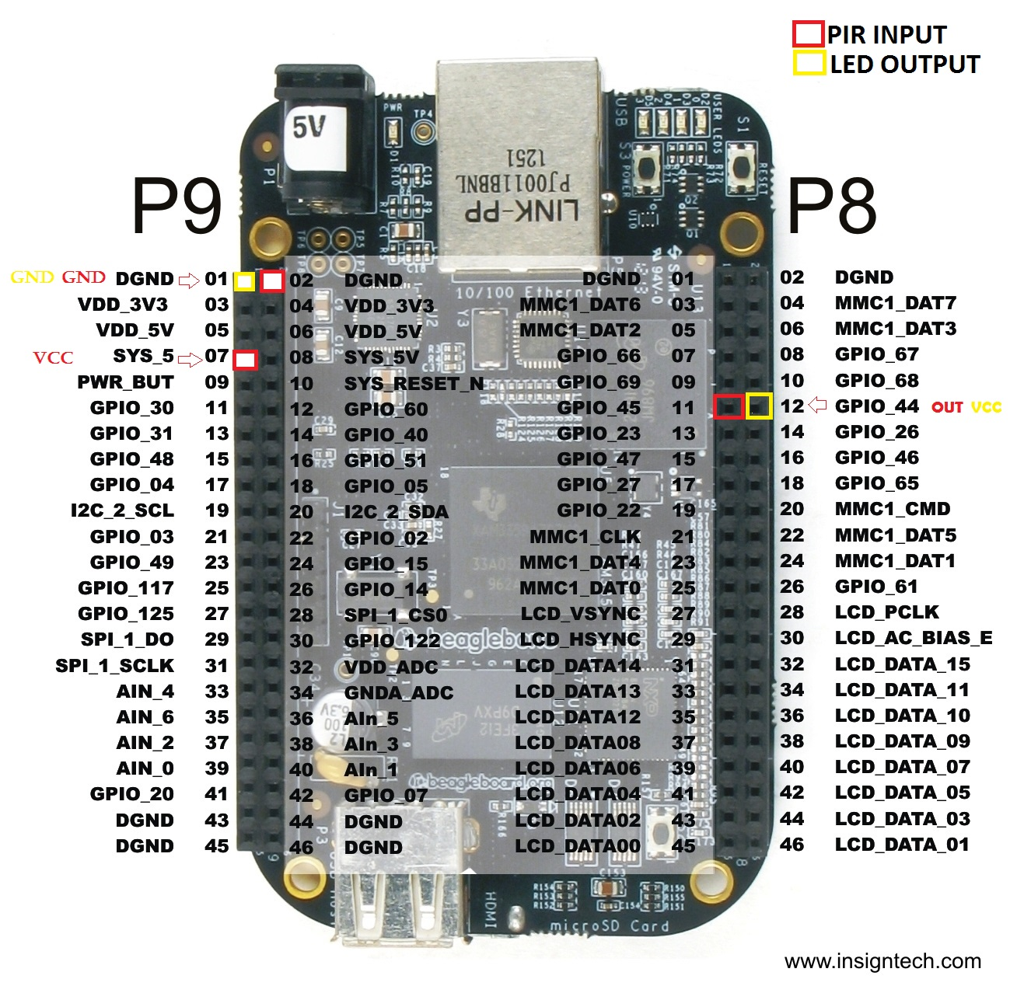

# LED

The positive (+) side of the LED to P8_12 and negative (-) of the LED to P9_01.

# PIR

We plugged the VCC of the PIR sensor to PIN P9_07 and the GND o P9_02 and plugged OUT to P8_11.